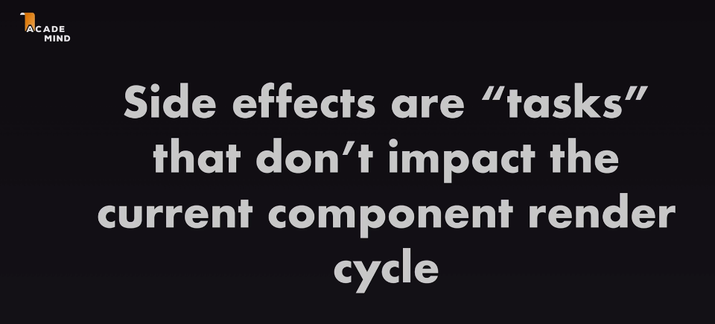

The idea behind useEffect is that this function which you pass a 1st argument, will be executed after every component execution.

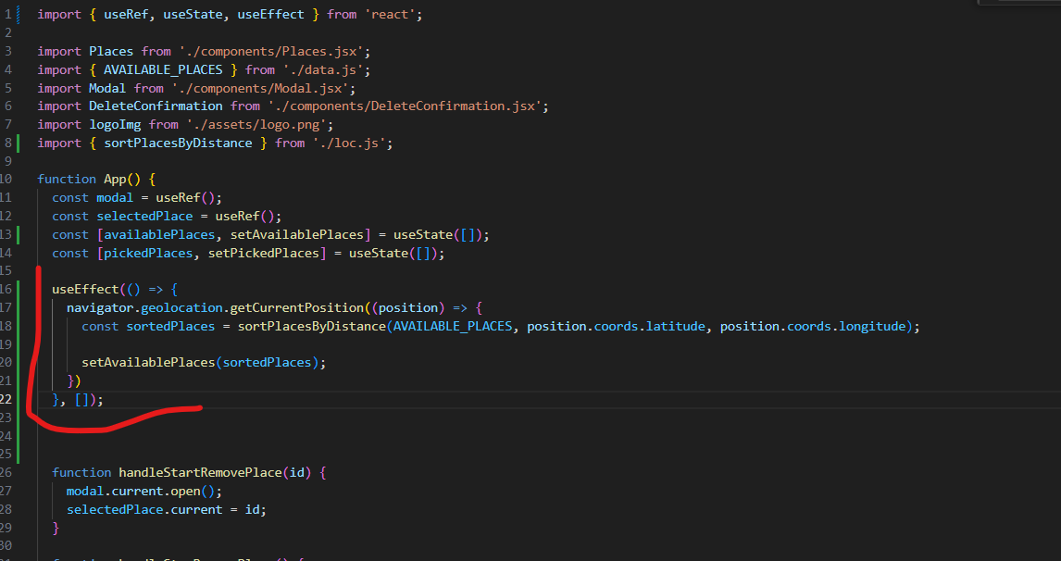

So the 2nd argument is the dependency array, which will enable React to re-execute function when the dependency array is changed. But in this case, since we pass an empty array, this function will only be executed once.

useCallback will make that function not re-executed when the app component is executed again

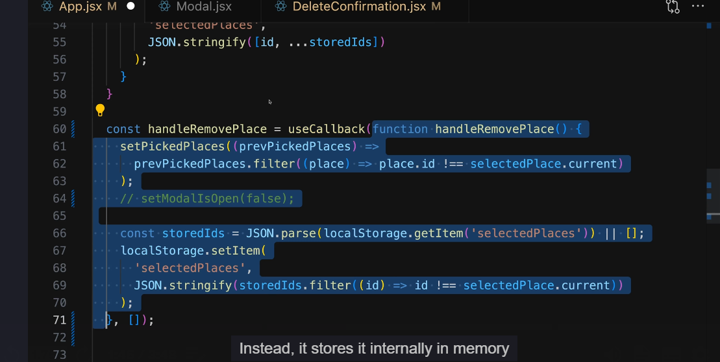

And we should use useCallback when passing functions as dependencies to useEffect()

